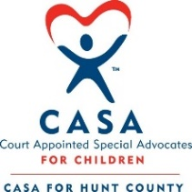
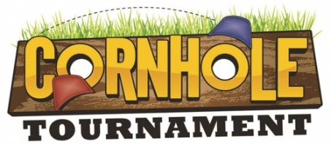
CASA for Hunt County

Saturday, February 27, 2021 Gates and concessions open at 12:00 PM. Bags fly at 1:00 PM
Location: Don Howard Stadium (Wolfe City High School Football Field)
Teams:
- There is a 64-team limit so make sure to pre-register
- Entry Fee: $100.00 per team (price includes meal ticket and a CASA event t-shirt)
- Two person Cornhole Teams
- A player cannot be on more than 1 team
- Double Elimination format - must lose twice to be out of the tournament.
- Must use Official CASA game bags and game Board
- Plaques/Trophies for 1st-3rd place teams

Sponsorship of Hole:
*Silver - $250 – $499 *Gold - $500- $999 *Platinum - $1,000+
- Sponsorship level recognized on the event t-shirt
- Sponsorship level recognized on CASA for Hunt County website and CASA for Hunt County social media
- Sponsorship level recognized on High School Digital Marquee along Hwy 34 from March 5- March 12
- Sponsorship level recognized on the live feed on the NFHS Network. If the sponsor, or representative, is available, then they will have multiple opportunities to speak about their organization during play-by-play action. If the sponsor is unavailable, please provide bio of your company/organization and any other information to promote.

Spectating Information
- Spectator Tickets on sale at gate: $15 per person (covers entrance and meal combo)
- Concession stand will be open for additional drinks and candy.
- All team and spectator tickets include: choice of pulled pork sandwich or hamburger, chips and a drink
- Fun for kids (face painting and other creative games)
- No alcohol or tobacco products may be sold or consumed on property
- No outside coolers, food, or beverage *exceptions for babies and/or specific dietary restrictions
- Silent Auction during event
**Watch the event free and live by joining us for at www.nfhsnetwork.com and searching for Wolfe City ISD
---------------------cut -------------------------------------cut -----------------------------------cut-------------------------------

Registration of Team
Pre-Registration is open Dec. 1, 2020 – Feb. 7, 2021. On-Site Registration on event date is available from 11:30am-12:30pm.

Option #1: Mail Registration of Team section and a check, made payable to: CASA for Hunt County, to:
CASA for Hunt County
P.O. Box 1571
Greenville, Texas 75403
*CASA will contact you when registration information and the payment has been received.

Option #2: Email Registration of Team information to: casa4huntcounty@msn.com. A link and instructions for a PAYPAL payment will be emailed.

Team Name: ________________________________________

Team Member #1: ______________________________ Team Member #2: ________________________________

Contact phone #: __________________________ Contact phone #: __________________________

T-shirt Size (circle one): S M L XL 2XL 3XL 4XL T-shirt Size (circle one): S M L XL 2XL 3XL 4XL

For more information, or to become a Cornhole Tournament Sponsor, please contact CASA at: casa4huntcounty@msn.com

Sponsorship Levels:
*Silver - $250 – $499 *Gold - $500- $999 *Platinum - $1,000+

Sponsorship Information

Sponsorship of the event runs from Dec. 1, 2020 – Feb. 7, 2021.

Option #1: Mail Sponsorship of Event section and a check, made payable to: CASA for Hunt County, to:
CASA for Hunt County
P.O. Box 1571
Greenville, Texas 75403
*CASA will contact you when registration information and the payment has been received.

Option #2: Email Sponsorship of Event information to: casa4huntcounty@msn.com. A link and instructions for a PAYPAL payment will be emailed.

Sponsor Business/Organization/Family Name: __________________________________________________

Contact name: ______________________________

Contact phone #: __________________________

Sponsorship donation: ______________________

T-shirt Size (circle one): S M L XL 2XL 3XL 4XL

Details of business/organization/family: (Information will be used during the event to recognize sponsor during the live feed of the event). If you wish to be an anonymous donor, please write Anonymous on the line below.

______________________________________________________________________________________________________

______________________________________________________________________________________________________

______________________________________________________________________________________________________

______________________________________________________________________________________________________

______________________________________________________________________________________________________

For more information, or to become a Cornhole Tournament Sponsor, please contact CASA at: casa4huntcounty@msn.com

Sponsorship Levels:
*Silver - $250 – $499 *Gold - $500- $999 *Platinum - $1,000+

